**1. Discuss the prototyping model. What is the effect of**

**designing a prototype on the overall cost of the**

**project?**

* It is a very famous S/W development model .
* In this model client is also invaled at the time of designing yhe system.
* In prototype model is modified until the client is not satisfied , then we jumped to the next case.
* The goal of prototype model to provide a system with overall functionality .
* Prototype model is an iterative development cycle between developer & client.
* We can also use the prototype model with other model.

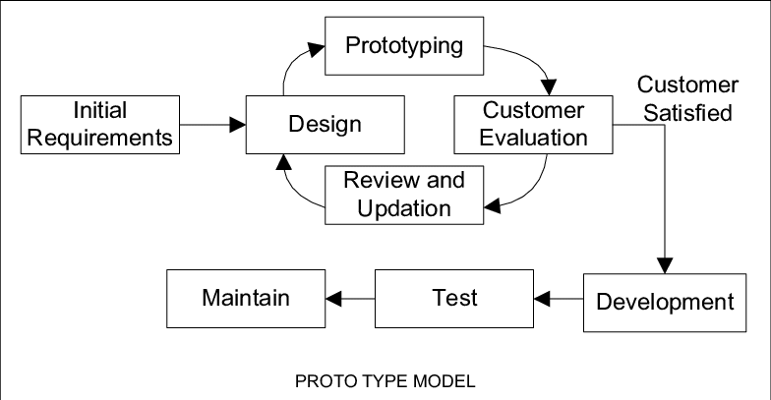

So, the effect of designing a prototype on the overall cost of a software project is to a actually **reduce the additional costs of restructuring and reframing it after its full-fledged development**- which might cost a fortune.

**2. Compare iterative enhancement model and**

**evolutionary process model**.

* ***Iterative enhancement model***

In this Model, you can start with some of the software specifications and develop the first version of the software. After the first version if there is a need to change the software, then a new version of the software is created with a new iteration. Every release of the Iterative Model finishes in an exact and fixed period that is called iteration.

The Iterative Model allows the accessing earlier phases, in which the variations made respectively. The final output of the project renewed at the end of the Software Development Life Cycle (SDLC) process.

* ***Evolutionary process model.***

Evolutionary model is a combination of Iterative and Incremental model of software development life cycle. Delivering your system in a big bang release, delivering it in incremental process over time is the action done in this model. Some initial requirements and architecture envisioning need to be done. It is better for software products that have their feature sets redefined during development because of user feedback and other factors. The Evolutionary development model divides the development cycle into smaller, incremental waterfall models in which users are able to get access to the product at the end of each cycle. Feedback is provided by the users on the product for the planning stage of the next cycle and the development team responds, often by changing the product, plan or process. Therefore, the software product evolves with time. All the models have the disadvantage that the duration of time from start of the project to the delivery time of a solution is very high. Evolutionary model solves this problem in a different approach.

**3. As we move outward along with process flow path of**

**the spiral model, what can we say about software**

Spiral model is one of the most important Software Development Life Cycle models, which provides support for Risk Handling. In its diagrammatic representation, it looks like a spiral with many loops. The exact number of loops of the spiral is unknown and can vary from project to project. Each loop of the spiral is called a Phase of the software development process. The exact number of phases needed to develop the product can be varied by the project manager depending upon the project risks. As the project manager dynamically determines the number of phases, so the project manager has an important role to develop a product using the spiral model.

The Radius of the spiral at any point represents the expenses(cost) of the project so far, and the angular dimension represents the progress made so far in the current phase

**The below diagram shows the different phases of the Spiral Model: –**

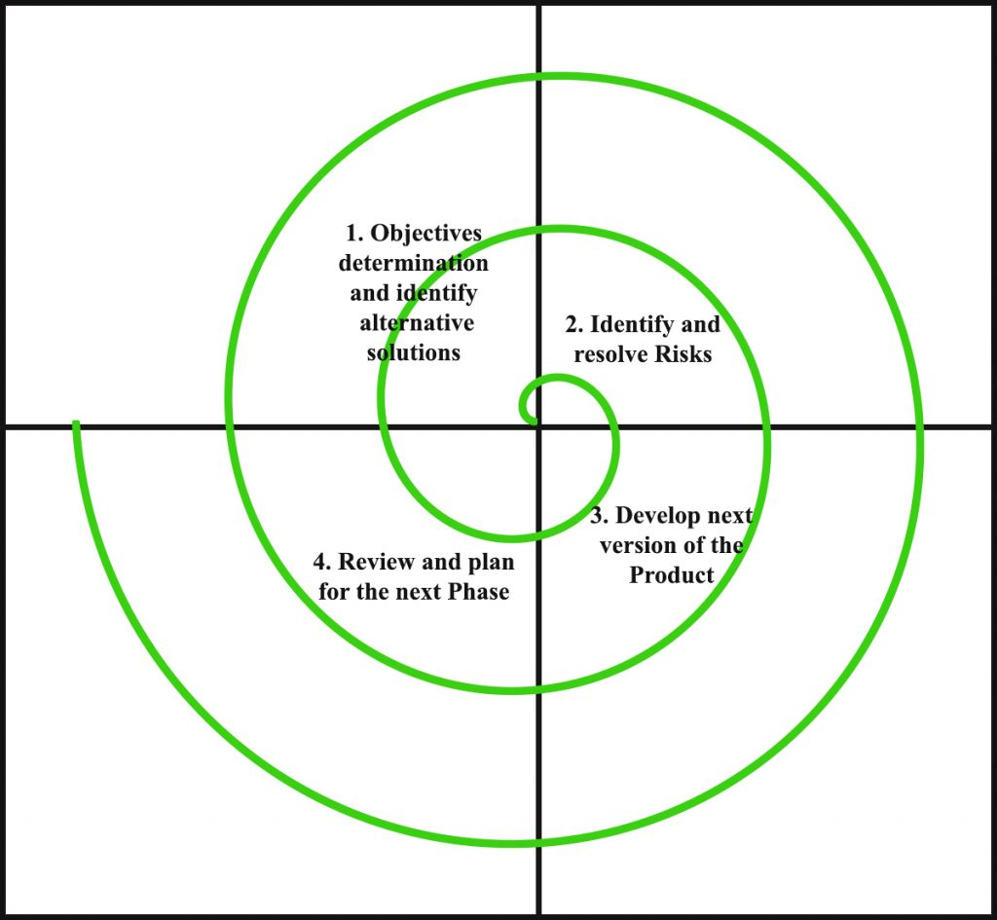

**4.** ***Explain the Scrum Agile methodology***

Scrum is an agile development methodology used in the development of Software based on an iterative and incremental processes. Scrum is adaptable, fast, flexible and effective agile framework that is designed to deliver value to the customer throughout the development of the project. The primary objective of Scrum is to satisfy the customer’s need through an environment of transparency in communication, collective responsibility and continuous progress. The development starts from a general idea of ​​what needs to be built, elaborating a list of characteristics ordered by priority (product backlog) that the owner of the product wants to obtain.

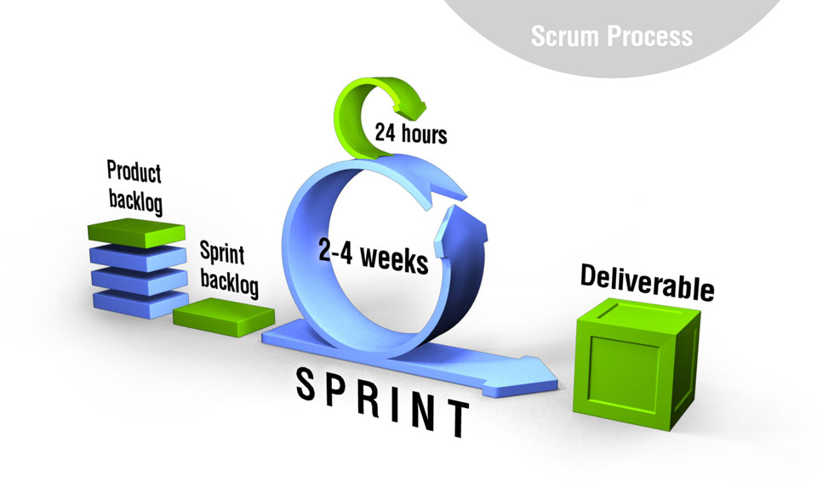

**5.** ***Explain the utility of Kanban CFD reports.***

The cumulative flow diagram (also known as CFD) is one of the most advanced Kanban and Agile analytics charts. It provides a concise visualization of the three most important metrics of your flow: Cycle time. Throughput.

Its main purpose is to show you how stable your flow is and help you understand where you need to focus on making your process more predictable. It gives you quantitative and qualitative insight into past and existing problems and can visualize massive amounts of data.

